PUBLIC NOTIFICATION

This is to notify the residents of Gelephu Throm that due to continuous heavy rainfall for the past few days, the Water Treatment Plant at Mouchhu, Gelephu, despite ensuring possible flood protection measures, was destroyed by the raging flood last night on 25th August 2021. On account of this, there will be water supply disruption for the Thromde residents for few days.

However, the Thromde Water Supply Team and the Management is consistently taking up immediate restoration works and will ensure that the Thromde residents receive the water supply as usual at the earliest possible.

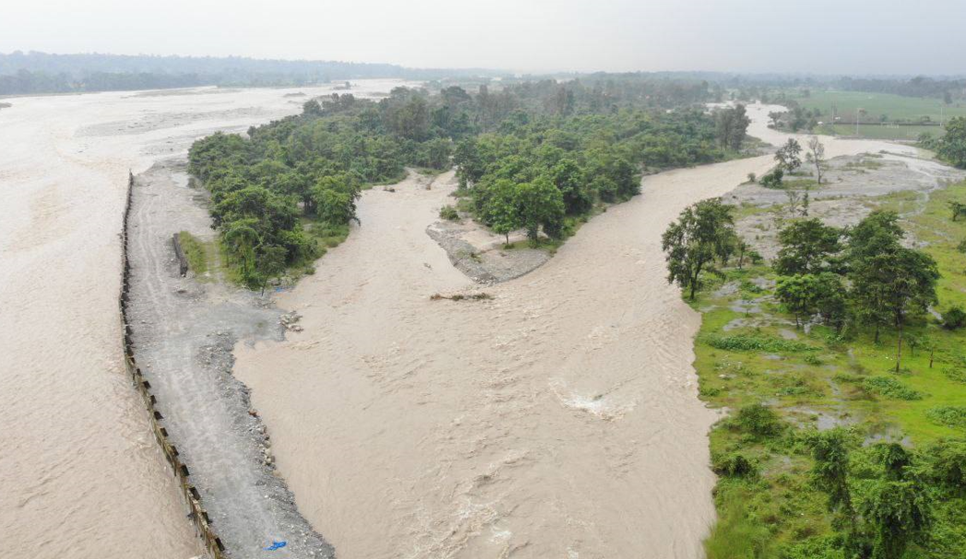
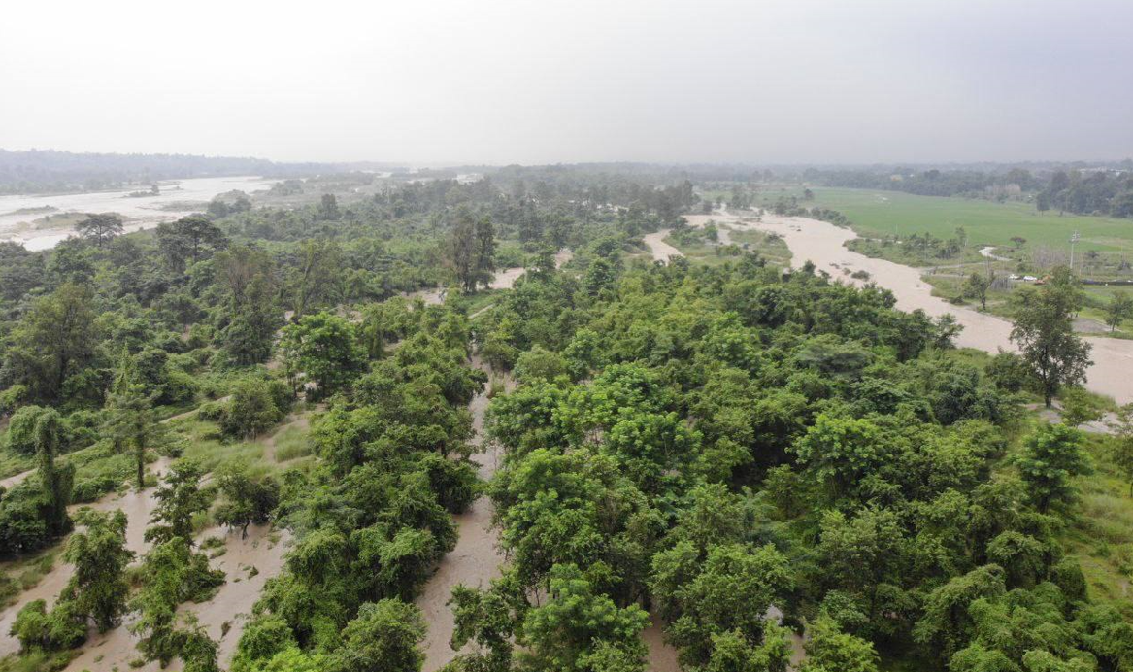

By Management

